WebStorm settings for Jade:

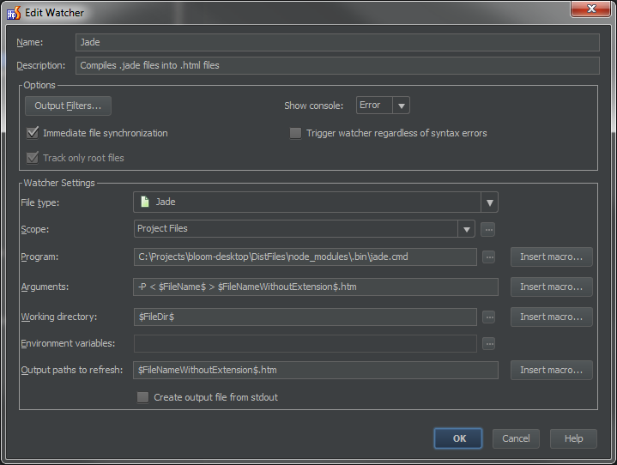

(This is a bit obsolete. Better to use <https://docs.google.com/document/d/1dYv-yQ18Jandi1TqDwzXIYrZf3M8NIgIQ8Y0rWlXVAI/edit?usp=sharing>, which has a section on WebStorm settings at the end.)

Webstorm settings for LESS:

The value for Arguments is (all on one line):

--include-path=$ProjectFileDir$/themes/bloom-jqueryui-theme/less --clean-css --clean-option=--s1 --clean-option=-b --no-color $FileName$

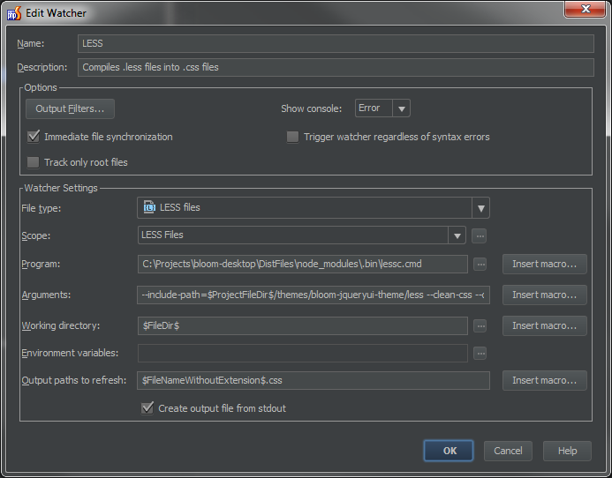

Because I am using an include path, it needs to be excluded from the list of locations that are processed by this file watcher. This is done with a custom scope, “LESS Files.”

WebStorm LESS scope.

The pattern for this scope is:

file:\*.less&&!file:themes/bloom-jqueryui-theme/less/\*

